AUTO IT

1. Download Auto it:

Link: https://www.autoitscript.com/site/autoit/downloads/

1. Start Auto It

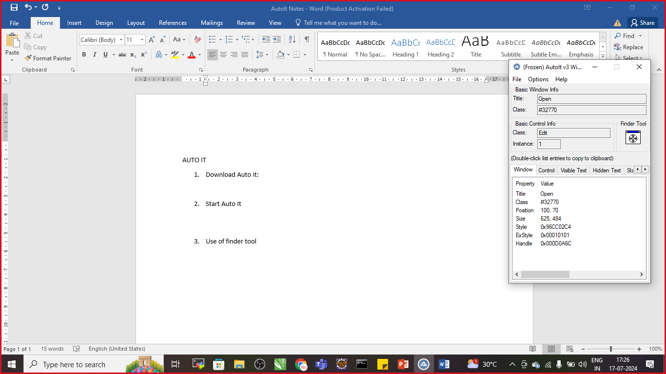

1. Use of finder tool

Open the Window Pop up That you want to Automate

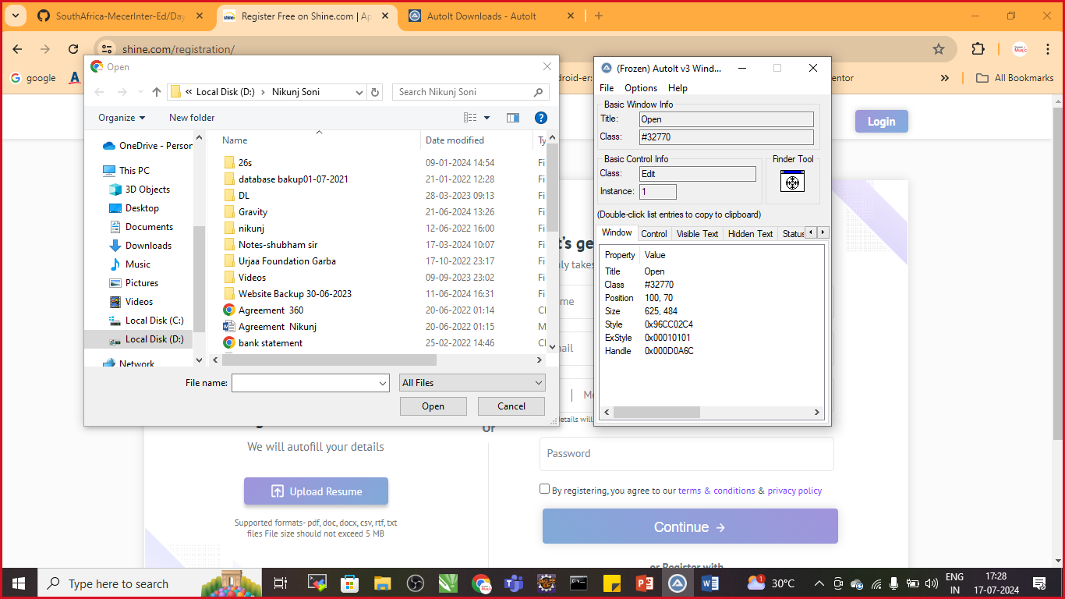

Click and Drag The Finder tool on Filename To Get the Credentials for Scripts

Title: Open

Class: Edit

Instance:1

Now click and drag finer tool on Open Button

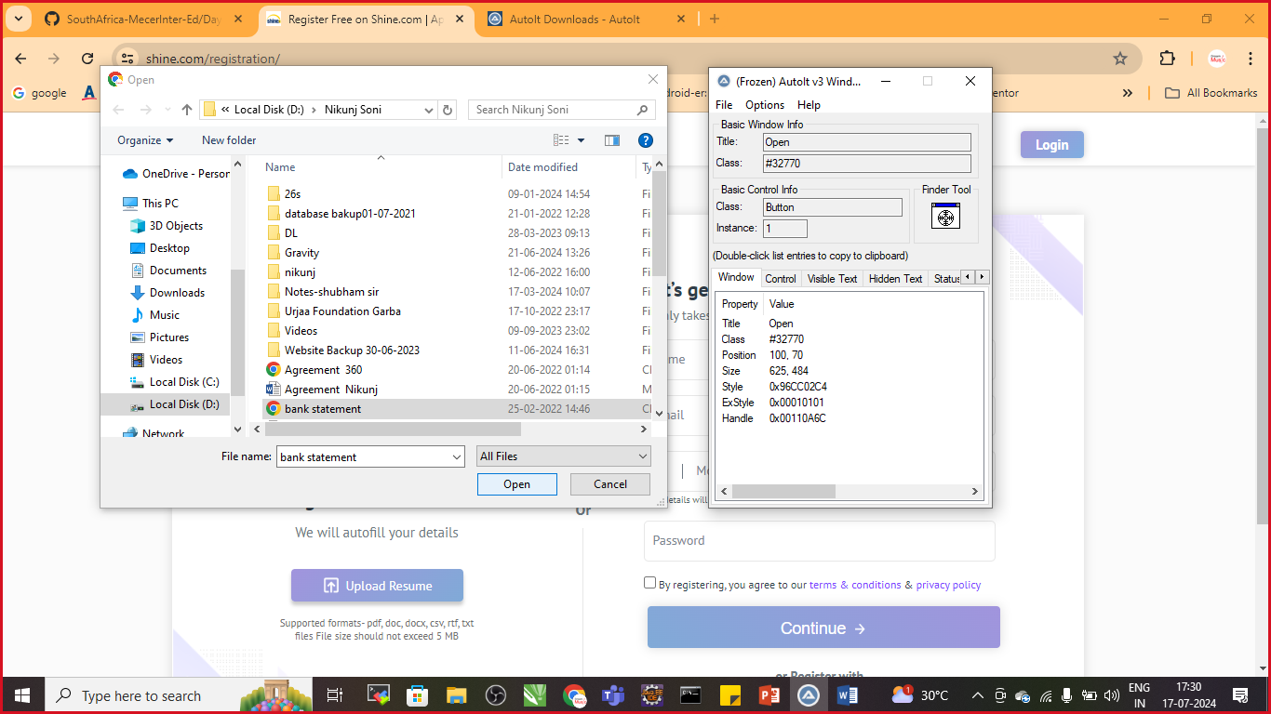

Note Down the Credentials for Script

Title:Open

Class:Button

Instance:1

Let’s write the script

Now goto>C:\Program Files (x86)\AutoIt3\SciTE

* Open SciTe.exe

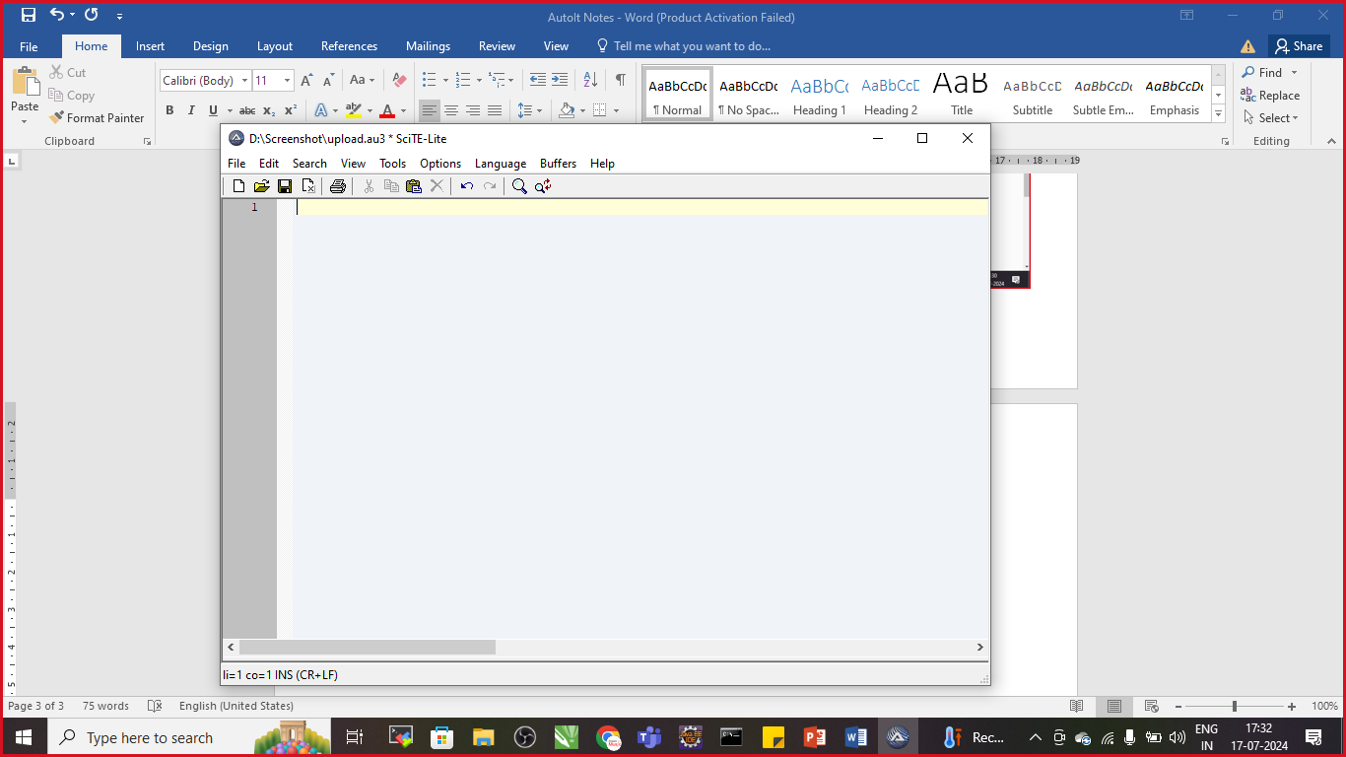

Add a Script:

ControlFocus("Open","","Edit1")

ControlSetText("Open","","Edit1","D:\2024\SouthAfrica\Day-3\Screenshot\autoit.pdf")

ControlClick("Open","","Button1")

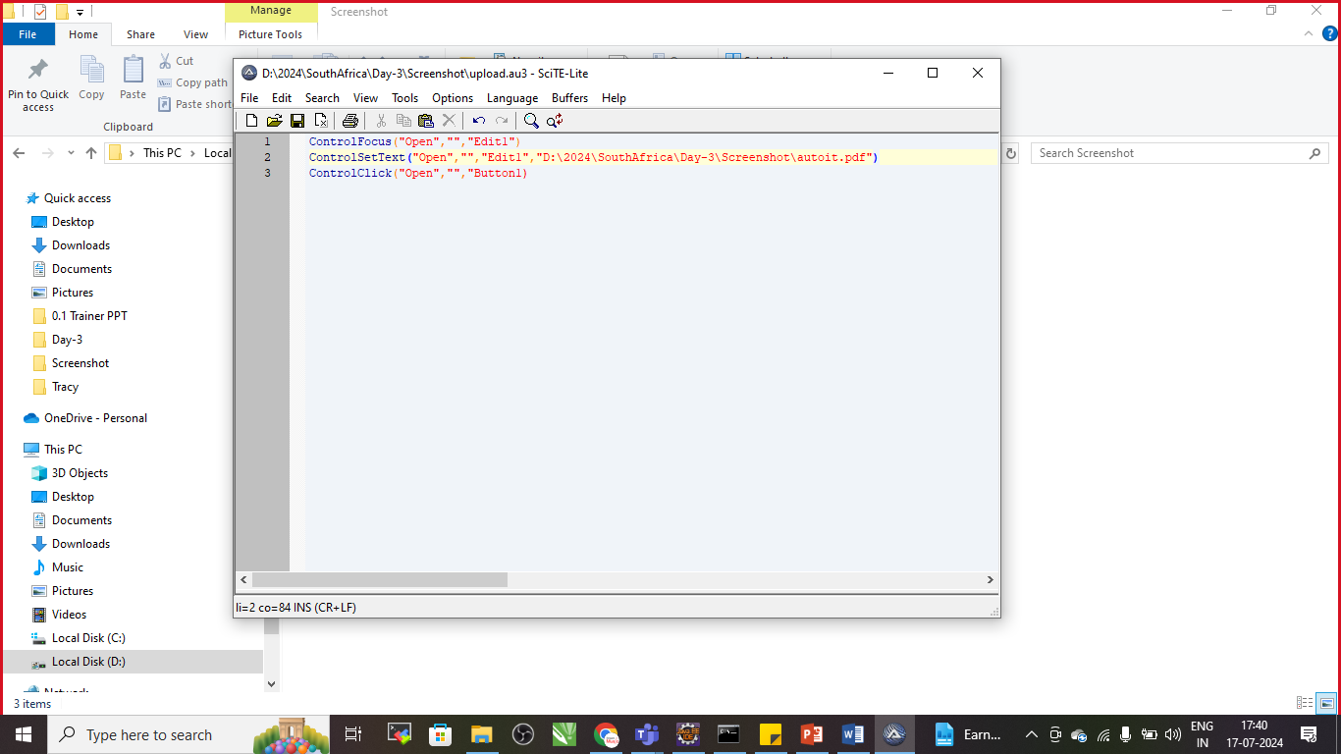

Save the file as >Save As >Your File.au3

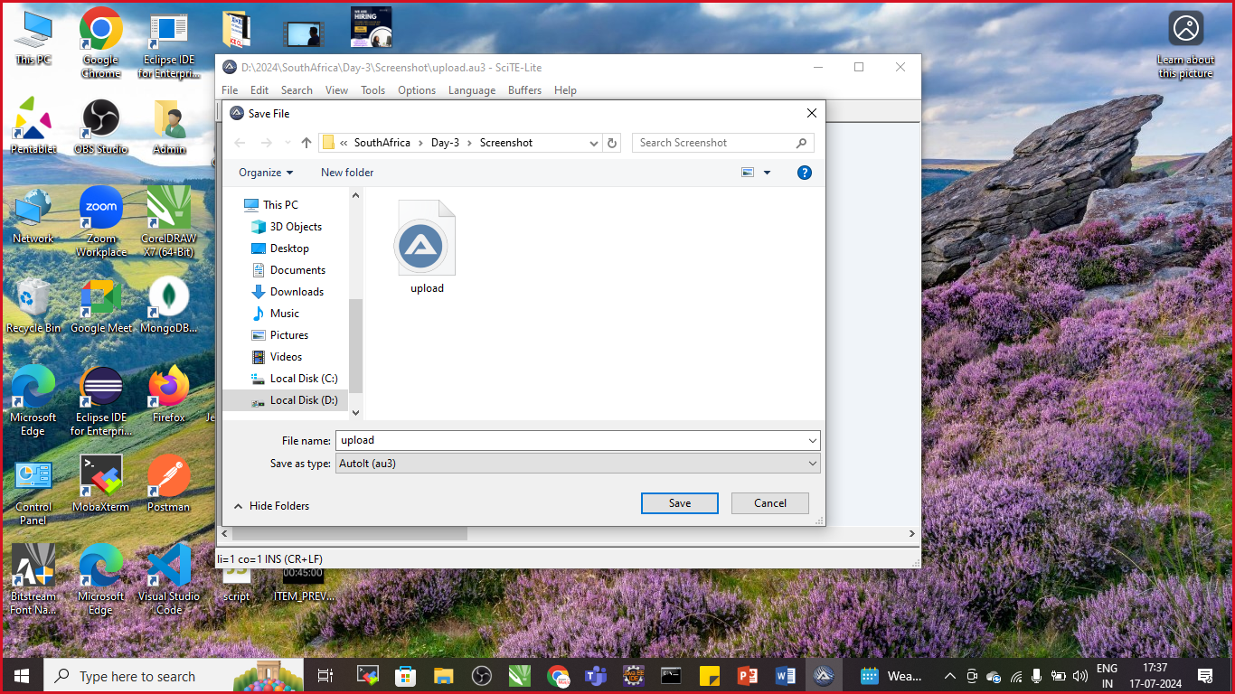

Goto>respective folder where Upload file is saved

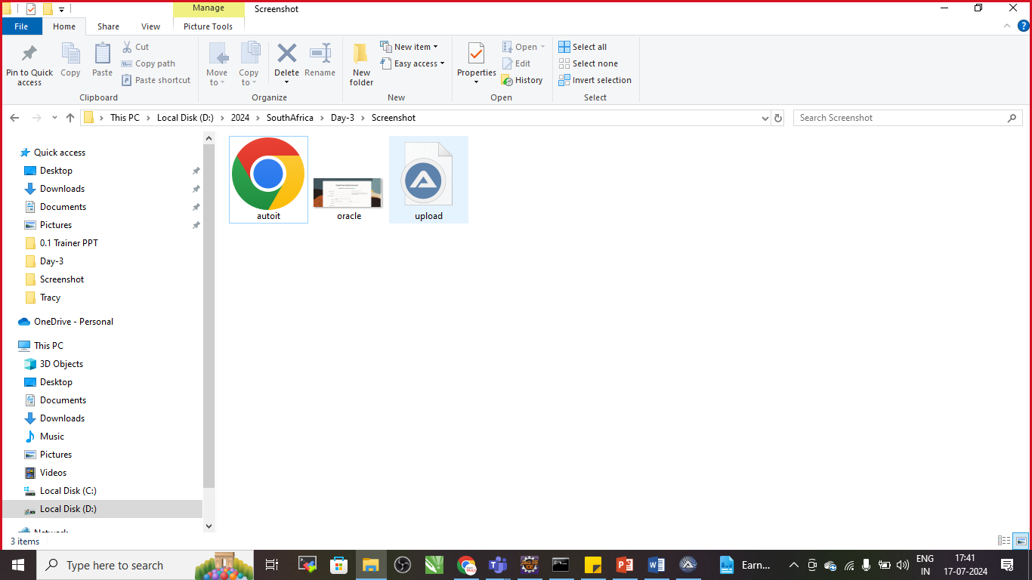

Right click on upload and compile script

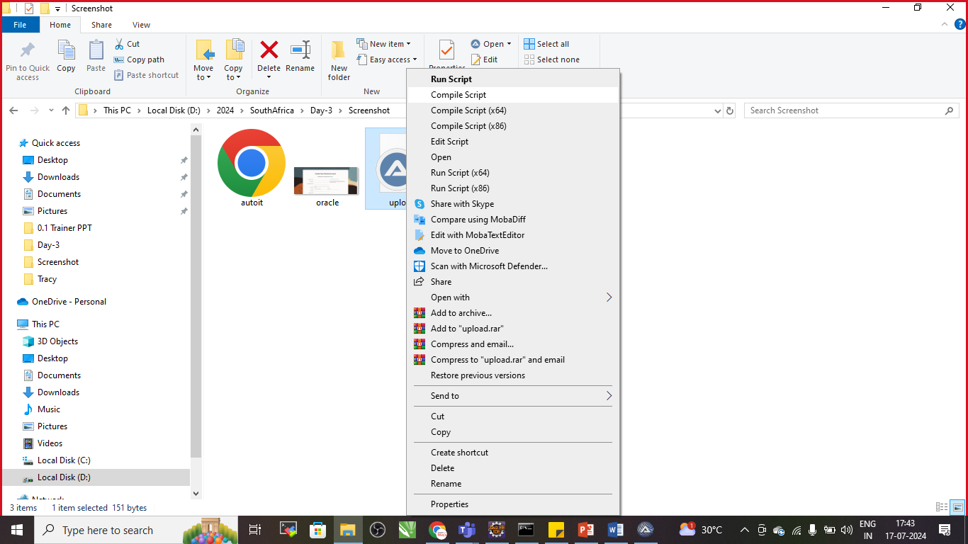

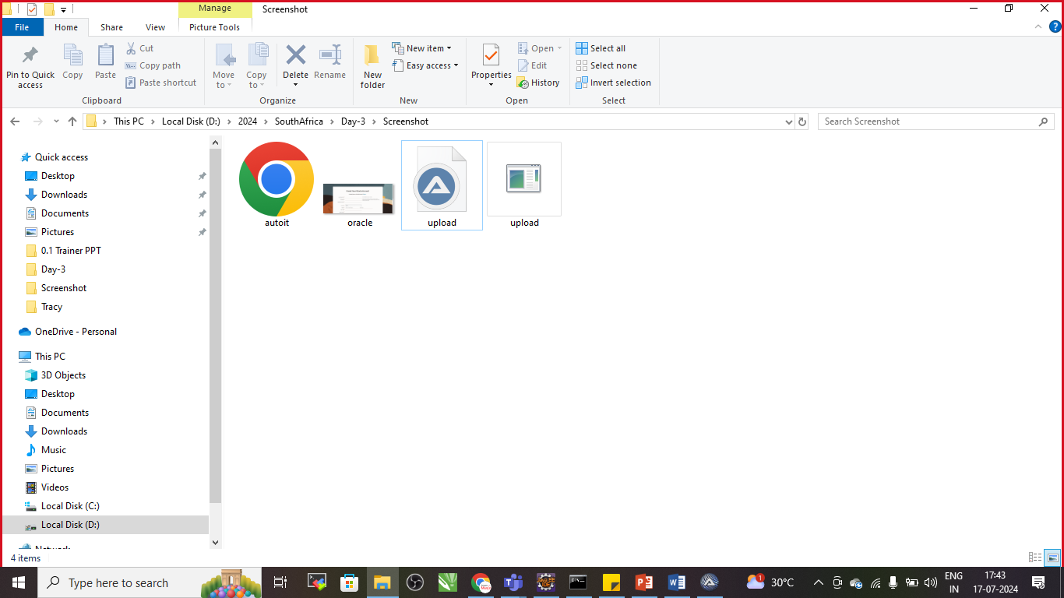

The file Generated is upload.exe File This will Automate Windows Automation

Write a java program :

**package** com.selenium.demo;

**import** java.io.IOException;

**import** org.openqa.selenium.By;

**import** org.openqa.selenium.JavascriptExecutor;

**import** org.openqa.selenium.WebDriver;

**import** org.openqa.selenium.WebElement;

**import** org.openqa.selenium.chrome.ChromeDriver;

**public** **class** AutoItExample {

**public** **static** **void** main(String[] args) **throws** IOException,InterruptedException {

System.*setProperty*("webdriver.chrome.driver","D:\\Phase-5\\Drivers2024\\chromedriver.exe");

WebDriver driver=**new** ChromeDriver();

driver.get("https://www.shine.com/registration/");

driver.manage().window().maximize();

WebElement name=driver.findElement(By.*id*("id_name"));

name.sendKeys("Nikunj Soni");

WebElement file=driver.findElement(By.*id*("id_file"));

JavascriptExecutor executor=(JavascriptExecutor) driver;

executor.executeScript("arguments[0].click()", file);

Thread.*sleep*(5000);

Runtime.*getRuntime*().exec("D:\\2024\\SouthAfrica\\Day-3\\Screenshot\\upload.exe");

//driver.close();

}

}